1) <?php

session_start();

?>

<!DOCTYPE html>

<html>

<head>

<meta charset="UTF-8">

<title>Session-based Login</title>

<style>

body {

background-color: brown;

}

h1 {

color: rgba(245, 230, 83, 1);

}

input {

width: 130px;

margin-bottom: 20px;

}

#box {

background-color: rgba(255, 255, 204, 1);

padding: 40px;

width: 600px;

font-size: 21px;

margin-left: 270px;

margin-right: 250px;

}

#timeout {

display: block;

}

#loginForm {

display: none;

}

#infoForm {

display: none;

}

.border {

padding: 5px;

border-top: solid black;

border-bottom: solid black;

font-weight: bold;

}

.logoutMsg {

margin: 10px;

color: red;

background-color: pink;

text-align: center;

}

button {

float: right;

padding: 5px;

border: 0px;

width: 50px;

border-radius: 4px;

background-color: rgb(92,184,92);

}

</style>

</head>

<body>

<h1><center><u>Session-based Login</u></center></h1>

<div id = "box">

<div id="timeout">

<div class="border">

Session Timed out

</div>

<div class="logoutMsg">

You are logged out due to inactivity for more than 15 minutes

</div>

<button onclick="dispLogin()">Login</button>

</div>

<form id="loginForm" action="#info" method="post">

<label for="username">Username</label>

<input name="user_name" id="user_name" type="text" placeholder="Username=Aryaman" required>

<br>

<label for="password">Password</label>

<input name="password" id="password" type="password" placeholder="Password=IWP123" required>

<br>

<button type="submit" name="login">Login</button>

</form>

<form id="infoForm" action="#success" method="post">

<label for="name">Name</label>

<input name="name" id="name" type="text" required>

<br>

<label for="city">City</label>

<input name="city" id="city" type="text" required>

<br>

<label for="phone">Phone No.</label>

<input name="phone" id="phone" type="text" required>

<br>

<button type="submit" name="login">Submit</button>

</form>

</div>

<script>

function dispLogin() {

var current = document.getElementById("timeout");

current.style.display="none";

var next = document.getElementById("loginForm");

next.style.display="block";

}

function dispInfo() {

var current = document.getElementById("loginForm");

current.style.display="none";

var current = document.getElementById("timeout");

current.style.display="none";

var next = document.getElementById("infoForm");

next.style.display="block";

}

function dispTimeout() {

var current = document.getElementById("infoForm");

current.style.display="none";

var next = document.getElementById("timeout");

next.style.display="block";

}

</script>

<?php

if (isset($_POST['login']) && !empty($_POST['user_name']) && !empty($_POST['password']))

{

if ($_POST['user_name'] == 'Aryaman' && $_POST['password'] == 'IWP123')

{

$_SESSION['user_name'] = 'Aryaman';

$_SESSION['activeTime'] = time();

}

else

echo '<script type="text/JavaScript">

alert("Incorrect Password!!");

dispLogin();

</script>';

}

if (isset($_SESSION['user_name']))

{

if ((time() - 15*60 > $_SESSION['activeTime']))

{

unset($_SESSION);

session_destroy();

echo '<script type="text/JavaScript">

dispTimeout();

</script>';

}

else

{

$_SESSION['activeTime'] = time();

echo '<script type="text/JavaScript">

dispInfo();

</script>';

}

}

?>

</body>

</html>

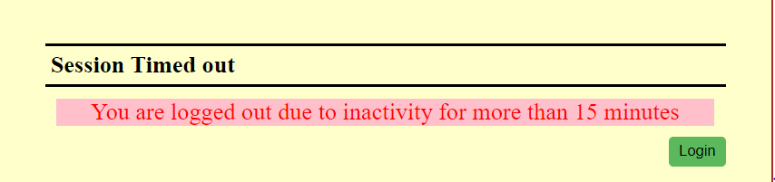

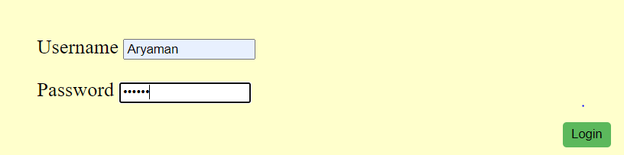

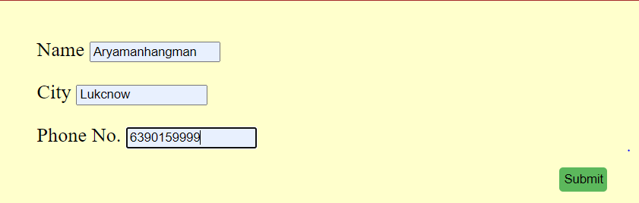

2) <?php

$myfile = fopen("newfile.txt", "w") or die("Unable to open file!");

for($i=0;$i<90;$i++)

{

$v=mt_rand(0,9);

fwrite($myfile,$v);

}

fclose($myfile);

$myfile2 = fopen("newfile.txt", "r") or die("Unable to open file!");

$a=array();

for($i=0;$i<15;$i++)

{

array_push($a,fread($myfile2,"1"));

}

echo "<h1>Here are the first 15 numbers from the file</h1>";

print_r($a);

echo "<br>";

echo "<h3>The numbers with odd occurences</h3>";

$t=0;

for($i=0;$i<15;$i++)

{

for($j=1;$j<15;$j++)

{

if($a[$i]==$a[$j])

{

$t=$t+1;

}

}

if($t%2!=0)

{

echo $a[$i]." ";

}

}

?>

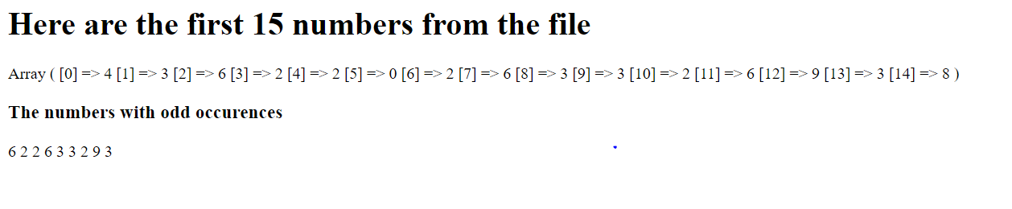

3) <?php

$to_email = "aryaman.mishra73@gmail.com";

$subject = "Daisy";

$body = "How do you do?my dear friend!";

$headers = "From: aryaman.mishra73@gmail.com";

if (mail($to_email, $subject, $body, $headers)) {

echo "Email successfully sent to $to_email...";

} else {

echo "Email sending failed...";

}